
Holy Cross College

Semester 2 Examination 2012

Multiple Choice Booklet

Year 10 Science
Please place your student identification label in this box
(Modified)

Student Name
Student’s Teacher

Time allowed for this paper

Reading time before commencing work: 10 minutes
Working time for paper: 100 minutes

Materials required/recommended for this paper

To be provided by the supervisor

This Question/Answer Booklet
Data Sheet

To be provided by the candidate

Standard items: pens, pencils, eraser, correction fluid, ruler, highlighters.
Special items: non-programmable calculators satisfying the conditions set by the School Curriculum and Standards Authority for this course.

Important note to candidates

No other items may be taken into the examination room. It is your responsibility to ensure that you do not have any unauthorised notes or other items of a non-personal nature in the examination room. If you have any unauthorised material with you, hand it to the supervisor before reading any further.
SECTION 1 MULTIPLE CHOICE (55 marks)

Make a choice of answer and mark it with a cross on the answer sheet in the answer booklet.

1. An absolutely pure substance that cannot be broken down into any other substance is:

(a) a compound.
(b) an atom.
(c) a molecule.
(d) an element.

2. The number of electron shells used by an atom of an element is the same as the:

(a) period number of the element in the Periodic Table.
(b) mass number of the atom.
(c) group number of the element in the Periodic Table.
(d) atomic number of the element.

3. Which of the following contains ions?

(a) SO₂
(b) H₂O₂
(c) Li₂O
(d) P₂O₅

4. The valence electrons are:

(a) the number of total electrons an atom has.
(b) the number of electrons in the atom's outer shell.
(c) the number of electrons an atom has after it reacts.
(d) the number of electrons an atom has before it reacts.

5. Use your Periodic Table to decide which of the following group of elements are all metals.

(a) S, Cr, He.
(b) K, Fe, Ne.
(c) Ba, Ag, Cu.
(d) F, Cl, Mn.

6. The mass number of an atom is the total:

(a) number of protons and neutrons in the atom.
(b) number of protons in the atom.
(c) mass of the atom expressed in grams.
(d) charge on the nucleus of the atom.

7. The equation shown represents a stage in the formation of rust. What are the values of w, x, y and z
(in order) needed to balance this equation?

w Fe _{(s)} + x O₂ _{(g)} + y H₂O _{(l)}  z Fe(OH)₂ _{(s)}

(a) 2, 1, 2, 2.
(b) 2, 1, 1, 2.
(c) 1, 2, 1, 2.
(d) 4, 1, 2, 2.
8. The atom represented by the symbol 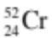 has:

(a) 24 protons, 52 neutrons and 24 electrons.
(b) 52 protons, 52 neutrons and 52 electrons.
(c) 24 protons, 28 neutrons and 24 electrons.
(d) 28 protons, 24 neutrons and 28 electrons.

9. The electronic configuration of the element with atomic number 16 is:
(Hint: Draw its electron configuration diagram to show the number of electrons.)

(a) 2, 8, 6.
(b) 8, 8.
(c) 2, 2, 8, 4.
(d) 2, 14.

10. Which of the following statements concerning groups in the Periodic Table is not correct?

(a) Groups contain either all metals or all non-metals.
(b) Groups contain elements with similar chemical properties.
(c) Groups are the vertical columns in the table.
(d) Groups are numbered using the Roman numerals I to VIII.

11. Which of the following general equations is incorrect?

(a) metal oxide + acid  salt + water
(b) acid + metal carbonate  salt + carbon dioxide + water
(c) acid + metal hydroxide  metal oxide + water
(d) metal hydrogencarbonate + acid  salt + carbon dioxide + water

12. In this diagram of an atom, identify the correct labels for A, B, C and D respectively.

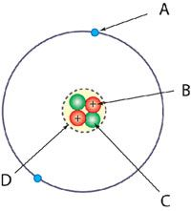

(a) Electron shell, neutron, proton and nucleus.
(b) Electron, proton, neutron and electron shell.
(c) Electron, proton, neutron and nucleus.
(d) Electron, neutron, proton and nucleus.

13. The formula for dinitrogen tetrahydride is:

(a) N₂H₅.
(b) N₄H₂.
(c) N₂H₄.
(d) N₅H₂.

14. If an electron is removed from an atom, which of the following would be true?

(a) The atom becomes positively charged because it now has more protons than electrons.
(b) The atom is now negatively charged because it has fewer electrons than protons.
(c) The atom is now positively charged because there are more electrons than protons.
(d) The atom is now negatively charged because it has fewer electrons.

15. Which of the following compounds is made up of 4 different elements and contains a total of 15
atoms?

(a) C₄H₉OH
(b) H₂SO₄
(c) Ca(HCO₃)₂
(d) (NH₄)₂SO₄

16. Identify what this diagram represents.

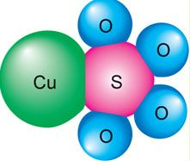

(a) An element.
(b) A compound.
(c) An impure substance.
(d) A pure lattice.

17. Use your Periodic Table to decide which of the following group of elements is most alike.
(Hint: They would all have similar chemical properties.)

(a) S, F, He.
(b) O, F, Ne.
(c) O, Cl, Kr.
(d) F, Cl, Br.

18. The number of electrons in a beryllium atom is:

(a) 4.
(b) 9.
(c) 13.
(d) 5.

19. Which of the following statements about an atom is correct?

(a) The nucleus consists of protons and neutrons.
(b) Most of the mass of an atom is due to the electrons.
(c) Protons and electrons are found in the nucleus.
(d) The electron cloud is positively charged.

20. What is the electronic configuration of magnesium?

(a) 2, 8, 2
(b) 2, 4, 4, 2
(c) 4, 2, 2, 4
(d) 4, 8

21. Which of the following words does not describe metals?

(a) lustrous
(b) malleable
(c) rigid
(d) ductile

22. Noble (inert) gases are all:

(a) unreactive.
(b) conductive.
(c) radioactive.
(d) rare.

23. Which of the following is a noble or inert gas?

(a) oxygen
(b) helium
(c) hydrogen
(d) carbon dioxide

24. The best definition of an ion is:

(a) an atom that has lost electrons.
(b) a type of bond.
(c) an atom with too many electrons.
(d) a charged atom.

25. Which one of the following equations is not balanced correctly?

(a) 3 NO _{(g)} + 2 O₂ _{(g)} → 3 NO₂ _{(g)}
(b) 2 C₂H₆ _{(g)} + 7 O₂ _{(g)} → 4 CO₂ _{(g)} + 6 H₂O _{(g)}
(c) HCl _{(aq)} + NaOH _{(aq)} → H₂O _{(l)} + NaCl _{(aq)}
(d) 2 H₂S _{(g)} + 3 O₂ _{(g)} → 2 H₂O _{(g)} + 2 SO_{2 (g)}

26. Which of the following is the most important factor in determining the chemical properties of an
element?

(a) The number of neutrons in the nucleus of its atoms.
(b) The number of protons in the nucleus of its atoms.
(c) The total number of electrons in its atoms.
(d) The group number of its atoms.

27. Cobalt sulphate is an example of:

(a) an ionic compound.
(b) a covalent compound.
(c) a molecule.
(d) None of the above.

28. Which element is represented by X in 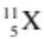?

(a) beryllium
(b) boron
(c) helium
(d) lithium

29. The periodic table:

(a) is a systematic chart listing all known elements.
(b) arranges elements from lowest to highest atomic number.
(c) separates the metals and non-metals.
(d) All of the above.

30. Positive ions are formed when atoms:

(a) gain protons.
(b) gain electrons.
(c) lose protons.
(d) lose electrons.

31. Calculate the velocity of a bus that travels between two traffic lights 145 metres apart in 20.0 seconds.
(Hint: Use v, s, t.)

(a) 7.00 ms⁻¹
(b) 7.25 ms⁻¹
(c) 6.25 ms⁻¹
(d) 7.50 ms⁻¹

32. Acceleration is defined as:

(a) the rate of change of speed.
(b) the rate of change of displacement.
(c) the rate of change of distance.
(d) the rate of change of velocity.

33. A decreasing rate of change of velocity could be called:

(a) positive acceleration.
(b) negative velocity.
(c) deceleration.
(d) braking.

34. In the absence of air resistance:

(a) heavier objects would accelerate toward the ground faster than lighter ones.
(b) more streamlined objects would accelerate toward the ground faster than less streamlined ones.
(c) all objects regardless of mass would accelerate toward the ground with the same velocity.
(d) objects with more mass would accelerate toward the ground faster than objects with less mass.

35. What is the acceleration of a car if it increases its velocity from 5.00 ms⁻¹ to 15.0 ms⁻¹ in 4.00 s?
(Hint: Use v, u, a, t.)

(a) 2.50 ms⁻²
(b) 2.50 ms⁻¹
(c) 150 ms⁻²
(d) 5.20 ms⁻²

36. Look at the graphs below.

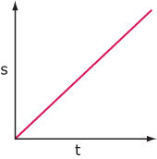
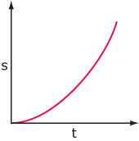
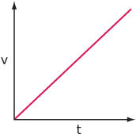
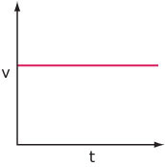

A B C D

37. The graphs above that show a vehicle with constant velocity are:

(a) B and C.
(b) A and C.
(c) A and B.
(d) C and D.

38. The sample of ticker tape below shows:

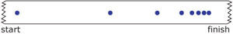

(a) a uniformly decelerating vehicle.
(b) a stationary vehicle.
(c) a uniformly accelerating vehicle.
(d) a vehicle travelling at a constant velocity.

39. The change in position of an object and its direction is known as:

(a) displacement
(b) distance
(c) average speed
(d) average velocity

40. How long would a car travelling at a speed of 60 kmh⁻¹ take to cover a distance of 90 km?
(Hint: Use speed, d, t and work in km and hours.)

(a) 1½ hours
(b) 2 ½ hours
(c) 3 ½ hours
(d) 4 ½ hours

41. Which line on the following graph represents a deceleration?

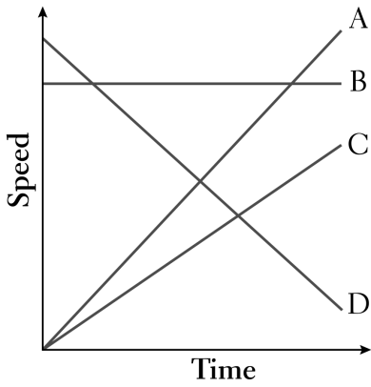
(a) A
(b) B
(c) C
(d) D

42. Which of the following is not a vector quantity, which has both size and direction?

(a) velocity
(b) acceleration
(c) energy
(d) force

43. The size of the acceleration acting on an object of mass 10 kg that has a net force of 3.0 N acting on it
will be:
(Hint: Use F, m, a.)

(a) 13 ms⁻².
(b) 3.33 ms⁻².
(c) 0.3 ms⁻².
(d) 30 ms⁻².

44. An object starts from rest and accelerates at 5.0 ms⁻². After 4.0 seconds, its velocity will be:
(Hint: Use v, u, a, t.)

(a) 0 ms⁻¹.
(b) 10 ms⁻¹.
(c) 20 ms⁻¹.
(d) 30 ms⁻¹.

45. The tendency of an object to stay at rest or continue moving if moving is called:

(a) inertia.
(b) weight.
(c) friction.
(d) work.

46. Newton’s Law, known as the Law of Inertia, is:

(a) his first law.
(b) his second law.
(c) his third law.
(d) none of the above.

47. "If an object has zero acceleration, the object must be at rest". This statement is:

(a) always correct.
(b) sometimes correct.
(c) never correct.

48. An object is acted upon by a push force of 50 N forwards and a total frictional force of 40 N. The nett
force will be:

(a) 10 N backwards
(b) 10 N forwards
(c) 90 N backwards
(d) 90 N forwards

49. The size of the acceleration acting on an object of mass 10.0 kg that has a nett force of 3.0 N acting on
it will be:
(Hint: Think of the resultant force and use F, m, a.)

(a) 13.0 ms⁻².
(b) 3.3 ms⁻².
(c) 0.3 ms⁻².
(d) 30.0 ms⁻².

50. When you hit a tennis ball with a tennis racquet, the action force is the force of the racquet hitting the
ball and the reaction force is:

(a) the ball hitting the racquet.
(b) the jarring force you feel through your hand.
(c) the weight force on the ball.
(d) the weight force on you.

51. An object has a mass of 250 kg . It would have a weight of closest to:
(Hint: Use F, m g.)

(a) 2.5 N
(b) 25 N.
(c) 250 N.
(d) 2500 N.

52. A driver noticed that his speedo reading was 118.8 kmh⁻¹. Which of the following represents the
speedo reading in ms⁻¹?

(a) 11880 ms⁻¹
(b) 33 ms⁻¹
(c) 118 ms⁻¹
(d) 330 ms⁻¹

The following diagrams represent the marks made on four separate tapes by the timing device as
the cart moves.
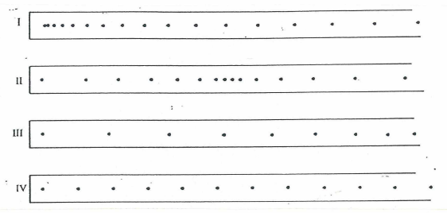
53. Which one of the diagrams best indicates that the cart was slowing down throughout the recorded time
interval?

(a) I (b) II (c) III (d) IV

54. Which one of the diagrams best indicates that the cart started from rest and accelerated?

(a) I (b) II (c) III (d) IV

55. Which one of the diagrams best indicates that the cart was travelling at constant speed?

(a) I (b) II (c) III (d) IV

END OF SECTION 1

